Palo Alto Licensing/Operating System Upgrade

Reed Holman | Cyber Security | 10/6/2022



Purpose: At this point our firewalls are fully operational and configured with a SOHO setup. However, they are not fully updated to the newest version. The point of this lab was to make sure our firewalls had all the necessary updates and were on the latest operating system.

Background: When you get a new or used firewall there is no guarantee that it will be at the newest version. The newest version will typically have fixes to problems that previous versions had, so it is smart to be on the newest version.

We upgraded to 10.2 which uses cloud-security and AI to improve security. This allows the firewalls to automatically learn from attacks that are happening elsewhere, and Palo Alto can send out and an update to all firewalls to keep them secure. It also came with other security features like better decryption and improved URL Filtering.

With the update we also got Administrator-Level Push which allows administrators to push out just their own configuration to firewalls. You can exclude configurations that are not complete which will help lower the chances of pushing out a configuration that would cause your firewall to go down.

Config:

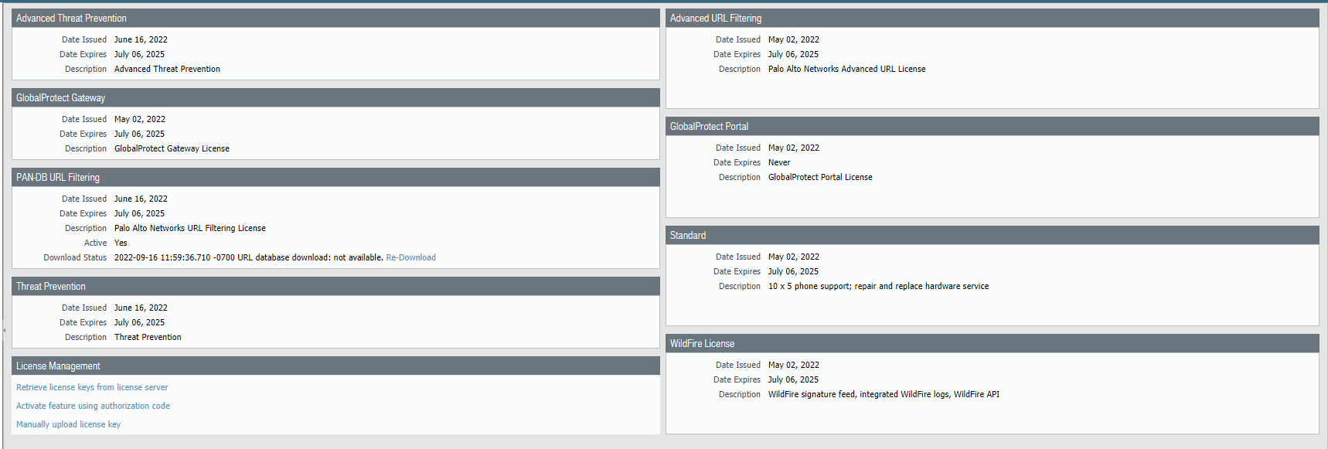

Go to retrieve new licenses

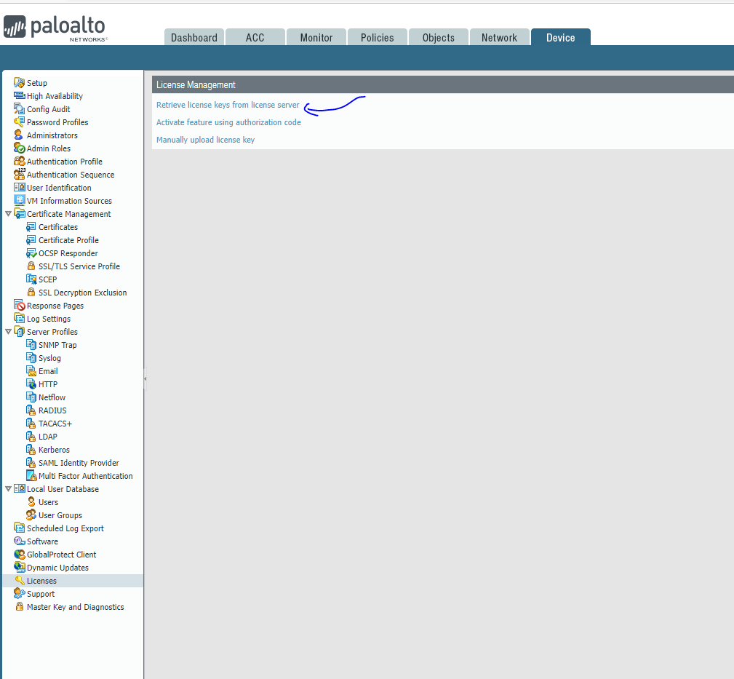

Click Retrieve keys from license server

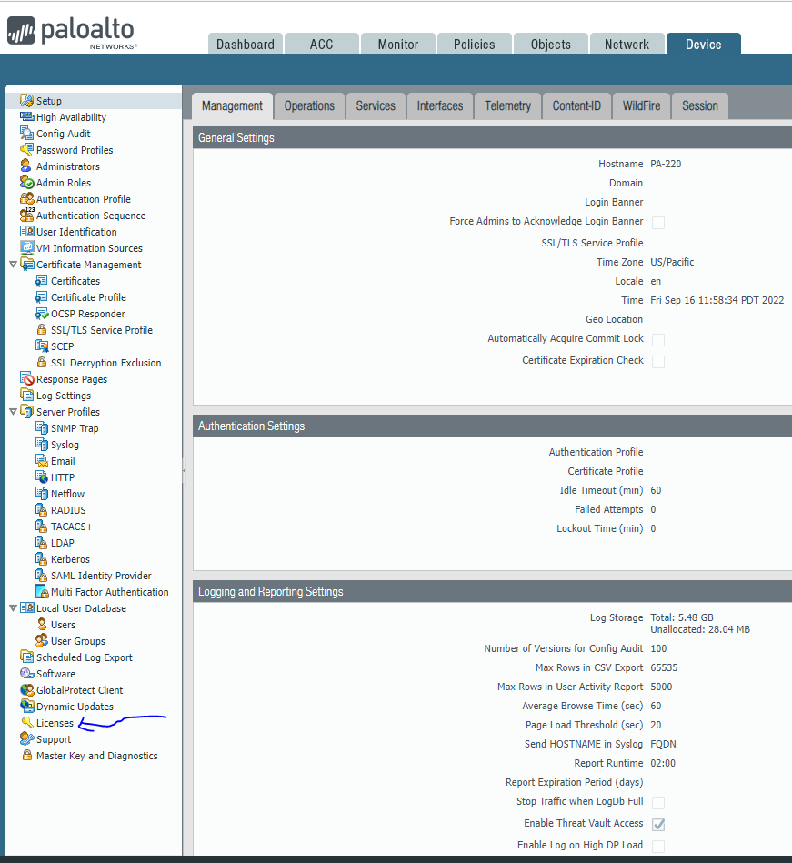

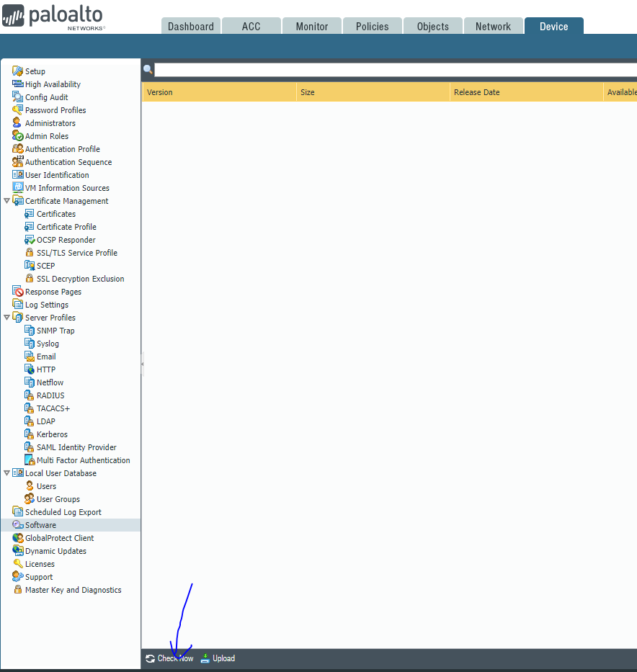

Click check now for new versions that are available

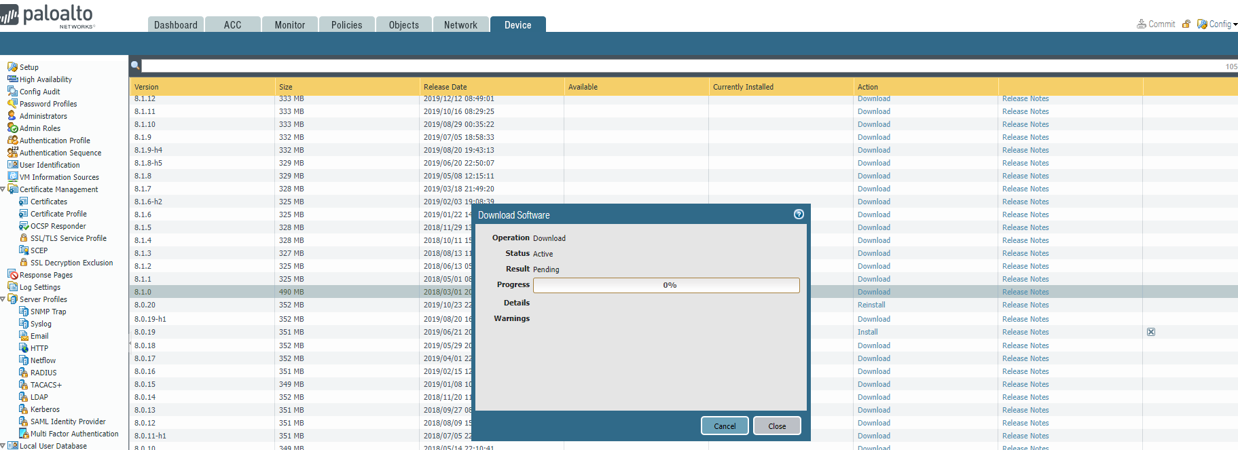

Do something else while waiting for download.

Problems:

We were having an error occur when we tried to fetch new licenses. This prevented us from doing any form of new software update. What we needed to do was change our DNS server and after we did that everything was working as intended.

Conclusion:

This Lab taught us how to get our Palo Alto version to use the newest operating system. So that we would have the best possible version and would ideally make it easier for us to manage and make changes to our firewall.